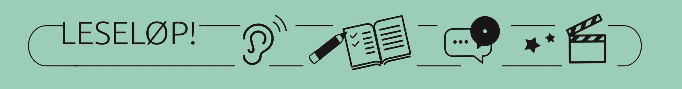
Assignment
What? | How? | Assumed time frame | Purpose (why)
Session 1 – Introduction
Hook:  Warming up exercise  Main text:  The Final Rap Battle  Outro:  Snippet and questions for reflection | Snippet:  A: Meryl Streep’s speech on Trump’s mocking of a disabled journalist: Meryl Streep's Golden Globes speech, annotated (youtube.com)  Pre-reading exercise  Reflection upon stereotypes.  B: Eminem’s final rap in the film 8 mile based on his life: The Final Rap Battle | Eminem VS Anthony Mackie | 8 Mile (2002) | TUNE (youtube.com)  Possible addition:  C: The Māori people’s HAKA tradition: Māori All Blacks perform their haka against Ireland (youtube.com)  Deeyah Khan’s interview on BBC as a baseline for the questions: “The UK is never going to be white again” - Muslim Deeyah Khan BBC interview ) | 15 min  40 min  5 min | Listening/watching and talking – getting them hooked  Get into the mindset of the upcoming topic.  Listen to, reflect upon, and attempt to gather thoughts upon the matter.  Have a broader approach to the topic than what is conventional for the students to experience/see that it is not only ethnicity that divides people.
Information:  Topic, aims, expectations and assessment | 1. The agenda for the upcoming sessions  2. Learning objectives  3. Product at the end | 5 min | Listening  For the students to know what they are doing, where this is heading, what they are to prove an understanding of/learn and what the assessment may be (informal/formal)
Session 2 – Defining racism and citizenship
Hook:  Warming up/  introducing  Main text:  Extract from Harry Potter and the Chamber of Secrets  Outro:  Compose multimodal products (posters) displaying definitions of racism | The universe and character orchestra of J. K. Rowling’s Harry Potter-series  A fictional text illustrating the matter: Extract from Harry Potter and the Chamber of Secrets, preferably the full chapter, but at least from page 86-89.  Read factual texts defining racism. Create their own.  A: A poster 4 types of racism FINAL_RSJI (seattle.gov)  B: A dictionary Racism Definition & Meaning - Merriam-Webster | 5 min  35 min  20 min | Reading, listening, talking, and writing.  Be able to extract content from factual and fictional texts and make use of the information gathered in their own texts.  Write explanations/definitions, informative texts, using their own vocabulary after having read multiple texts.
Session 3 – Multiculturalism and tolerance
Hook:  Warming up exercise:  The responsibility of role models  Address the responsibilities of role models within sports (as a bridge to the main text.)  Main text: Addressing racism from Romelu Lukaku’s perspective  I've Got Some Things to Say by Romelu Lukaku (theplayerstribune.com)  Outro:  Questions for reflection | Address the responsibilities of role models within sports (as a bridge to the main text.)  Greatness Comes From Everywhere | No Room For Racism (youtube.com)  2: Factual text – autobiographical | 10 min  45 min  5 min | Listening, talking, and writing  Refreshing what is the topic in English class these days – “logging on” and pointing towards the main text of the session.  Reading a factual text and reflecting upon its content.  Be able to connect the reading experience to the main topic of the period – racism.
Session 4 – Where does the intolerance stem from?
Hook:  Warming up exercise:  Main text:  Trying to understand racism from Deeyah Khan’s perspective  Tedtalk:  What we don't know about Europe's Muslim kids | Deeyah Khan (youtube.com)  Outro:  Little Miss Eyeflap  Skylappjenta - Little miss eyeflap on Vimeo | Questions for reflection creating a bridge to the main text.  A Tedtalk as audio and transcript:  What we don't know about Europe's Muslim kids | Deeyah Khan (youtube.com)  Questions for reflection |  | Listening/watching, talking, and writing
Session 5 – Where does the intolerance stem from?
Where does the intolerance stem from? | The full session is given to the students working on their multimodal product. | 60 min | Listening, talking, creating and writing
Session 6 – Show products
Show  products |  | 60 min | Be inspired!

