Oppgaver til elevene
Equipment needed: Access to computers for searching up
information and writing.
Decoded aims:
Acquire skills through activities in the target language: recognise lyrical devices, speak, write, talk, interact, research, and apply knowledge.
Knowledge: Be familiar with van Gogh’s life – the personal and the professional
Critical reflection: Conscious use of sources

Session 1
Aims :
- Read, speak, and write using the target language.
- Learn about the artist Vincent van Gogh.
- Extract knowledge from factual texts in the target language and make use of this knowledge in your own creative texts

1: Warming up exercises
A: Life skills: «How do you know you master life?”
B: Art: Reflect upon the following questions:
- What is art?
- Why do artists create art?
2: Introductory exercise – gathering information, reading factual texts, assessing sources
A: What do you by now know about the man behind these pictures?
Collection - Van Gogh Museum (Filter: Artist, self-portraits and landscapes, paintings)
B: Learning more about the artist – background information
a: Read the two following articles:
Who is Vincent van Gogh? | Tate Kids
Vincent van Gogh - Students | Britannica Kids | Homework Help
(Possible to differentiate top right corner)
b: Based on the two diverse sources, compose a short biography on van Gogh including the intel you found most important.
Feel free to select the most important key words from your written text and present them visually in a word-cloud, while attaching the rest of the text.
3: Make use of provided knowledge
Make use of the information you have acquired by picking one of the writing exercises below.
a: Write a gallery pitch to your own gallery hosting a Vincent van Gogh-exhibition.
b: Write the script to your radio show “Morning tea with …” - today with Vincent van Gogh.
c: Write the blurb to Vincent van Gogh’s autobiography

Session 2
Aims :
- Be able to comment upon poems in a factual manner, using proper literary terminology and state the function of devices used.
1: Warming up – hot seat
In groups of approx. four – be given the following roles: van Gogh’s landlord, van Gogh’s mother/father, van Gogh’s brother Theo, and van Gogh’s ex-girlfriend
One by one take the “hot seat” and be interviewed by the others in your group. Use the target language, converse, stay in role and incorporate the knowledge and perception you now have.

2: Assignment
A: Literary analysis and interpretation
When studying literature – in this case a song lyric – one may choose to examine it in different manners. For instance, one may read it looking for the author’s typical writing style, the era’s significant traits – or purely studying the devices used and look for theme and message.
Do the following:
A: Do you feel Don McLean’s portrayal of Vincent van Gogh corresponds
with your impression of the artist?
B: What do you believe to be the theme and message here?
C: Do you feel Don MacLean includes van Gogh’s paintings in his symbolism
and imagery? Exemplify and elaborate your answer.
Listen to the full song: Don McLean - Vincent ( Starry, Starry Night) With Lyrics - YouTube
*Song lyrics given below*

The song “Vincent” by Don McLean
Starry, starry night
Paint your palette blue and gray
Look out on a summer's day
With eyes that know the darkness in my soul
Shadows on the hills
Sketch the trees and the daffodils
Catch the breeze and the winter chills
In colors on the snowy, linen land
Now, I understand what you tried to say to me
And how you suffered for your sanity
And how you tried to set them free
They would not listen, they did not know how
Perhaps they'll listen now
Starry, starry night
Flaming flowers that brightly blaze
Swirling clouds in violet haze
Reflect in Vincent's eyes of china blue
Colors changing hue
Morning fields of amber grain
Weathered faces lined in pain
Are soothed beneath the artist's loving hand
Now, I understand, what you tried to say to me
How you suffered for your sanity
How you tried to set them free
They would not listen, they did not know how
Perhaps they'll listen now
For they could not love you
But still your love was true
And when no hope was left inside
On that starry, starry night
You took your life as lovers often do
But I could have told you, Vincent
This world was never meant for one
As beautiful as you
Starry, starry night
Portraits hung in empty halls
Frameless heads on nameless walls
With eyes that watch the world and can't forget
Like the strangers that you've met
The ragged men in ragged clothes
The silver thorn of bloody rose
Lie crushed and broken on the virgin snow
Now, I think I know what you tried to say to me
How you suffered for your sanity
How you tried to set them free
They would not listen, they're not listening still
Perhaps they never will
Source: Vincent (Starry Starry Night) Don McLean - YouTube/ Don McLean – Vincent (Starry Starry Night) Lyrics | Genius Lyrics

Session 3
The full session is given to create a multimodal product. You are given the opportunity to select one out of six given cross-curricular tasks. Your product is to be handed in.
Tasks:

Velg et oppdrag
Dere skal gjennomføre et oppdrag om Vincent van Gogh ved å lage en digital fortelling. Det betyr at dere skal sette sammen ulike elementer, for eksempel verbaltekst, kunstbilder, fotografier, musikk, lyder, innleste dialoger, vitneutsagn, tanker eller refleksjoner, fortellinger, opplesing av brev og lignende i en presentasjon som lages på pc.
Presentasjonen skal ha et overordnet tema, og dere skal derfor velge ett oppdrag fra lista nedenfor. Presentasjonen skal vare mellom 5 og 10 minutter. Dere kan bruke verktøy som Book Creator, Creaza, PowerPoint, Movie Maker og lignende.

- I van Goghs hode
Hva foregikk i van Goghs hode? Hva var han opptatt av? Hva plaget ham? Hva gjorde ham lei seg? Hva gledet han seg over? Fortell først historien om van Goghs hode. Presenter også noe ved tankene hans dere kjenner dere igjen i.

- Historien om øret
Det finnes mange ulike teorier om van Goghs øre. Hva hendte egentlig? Fortell historien. Argumenter for hvorfor denne versjonen av fortellingen og kildene dere har brukt, er troverdige. Presenter noen tanker om hvorfor dere tror mennesker i dag fortsatt er opptatt av historien.

- To brødre
Van Gogh og broren hans Theo hadde et nært forhold hele livet, men det var ikke problemfritt. Fortell historien om de to brødrene. Presenter noen tanker om det å ha søsken eller ikke ha søsken. Hvorfor kan det være så flott, men likevel så vanskelig?

- Kunstbildene forteller!
Van Gogh er en av verdens mest kjente kunstnere. Ta oss med på en reise i kunsten hans og fortell om maleriene. Hvilke motiver har van Gogh i bildene sine? Hva kjennetegner hans måte å male på? Har maleriene noen mening eller historie bak seg? Del noen tanker om hva dere selv synes om kunsten. Begrunn meningene deres.

- Geni eller gal?
Var van Gogh en talentfull, kul og snill person, eller var han en særing, en kranglefant og en gal mann? Hvordan opplevde andre mennesker van Gogh da han levde, og hvordan framstilles han i dag? Fortell historien om personen Vincent. Inkluder noen tanker om hva dere ville ha spurt van Gogh om hvis dere møtte ham, og hvordan dere tror han ville ha oppført seg.

- På jakt etter gleder
Van Gogh var plaget med mange vonde og mørke tanker. Men det fantes også gode ting i livet hans. Hvilke gode ting var dette? Gå på jakt etter små og store gleder i van Goghs brev og malerier eller i tekster om ham. Presenter funnene deres og velg en spesiell glede dere forteller historien bak. Reflekter over hva dere selv finner glede i (for eksempel familie, venner, musikk, dataspill eller idrett).

Tilleggsressurser
Option 1:
Reading up on Vicent van Gogh using multiple sources
By using these different texts, you are to be able to elaborate on who Vicent van Gogh was, why he became famous, what kind of paintings he painted and provide a fun fact or two about him.
To evaluate your sources – use the CRAAP-test (Credible, Relevant, Authority, Accuracy, and Purpose. Link: The CRAAP Test - Evaluating Sources - Research Guides at Benedictine University Library)

Possible texts:
Listening: Artists in a Nutshell - Vincent van Gogh - BBC Sounds
Listening: Vincent van Gogh - BBC Sounds (Not the complete file! Approx 10 min.)
Reading: Biography of Vincent van Gogh
Reading: Vincent van Gogh - Van Gogh Museum
Reading: Vincent van Gogh - Post-Impressionist, Paintings, Artwork | Britannica

Option 2: Differentiating task
Compose a product with point of departure in van Gogh’s painting “Starry Night”. Use speech bubbles or other graphic art effects to point at and comment upon the different elements in the picture. Be sure to point to elements illustrating or referring to:
- His life
- His specific way of painting - techniques
- Typical features in van Gogh’s paintings
- The use of colours in the picture – and how you could interpret them.
- The specific elements in this picture in particular – for instance the stars or the buildings – and what you may read into these.

Option 3: Writing task – practicing composing paragraphs
Starry Night – poem. (60 min)
Warming up exercise:
A: Listen to the full song: Don McLean - Vincent ( Starry, Starry Night) With Lyrics - YouTube
B: Comment on each stanza with your own short notes what you feel each stanza refers to
a: Refresh/learn the following eight factual terms. Find them in the song – and comment
upon their function.
Theme, message, imagery, repetition, rhyme pattern, end rhyme, alliteration, comparison
b: What do you believe is the theme and message in the song?
c: Pick two of the literary devices used and compose full paragraphs commenting upon their use and function. Remember how you argue fully – using the complete staircase:

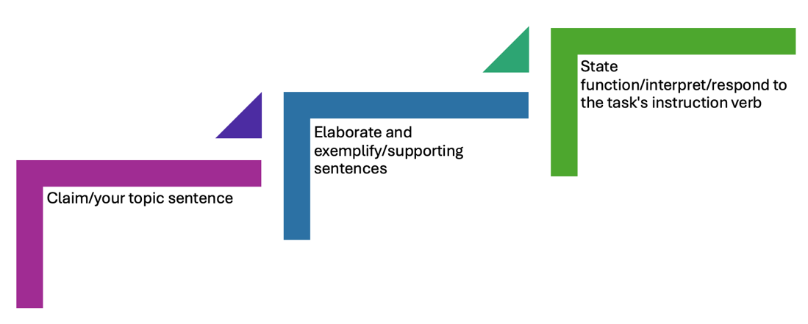

d: Do you feel Don McLean’s portrayal of Vincent van Gogh corresponds with your impression of the artist?

Option 4: Composing an article
Write a discursive text for handing in as a response to the following statement:
“Virginia Woolf, Vincent van Gogh and our own Edvard Munch are all world-famous artists recognised for their works, but who are known for struggling with their mental health as well. Do you believe great art – written, painted or shaped, often demands a higher level of creativeness than the commoner often possesses?
Writing frame
Component: | Remember: | Your text:
Title | Reflect your content  Be intriguing
Introduction | Informative and provide context. Explain the issue
Main body:  Aim for three full paragraphs.  1: Argue for it being true | Topic sentence (claim)  Supporting sentences  (elaborate, explain and exemplify)  Outro  (In accordance with your instruction verb, reflect/assess/… what your stated material above leads to. )  Remember signposting/linking words and phrases
2: Argue for it not being true
3: For, against or a bit of both
Ending:
Based on what you have found – provide solutions, conclusions or predictions, f.ex.

